CSC 220: Exploring Global Health Crisis Data  
FALL 2022 - Week 8

Research Assistant: Joori Almarzouki

jalmarzouki@uri.edu

horizontal line

# 28 October 2022

Joining Data

It is often necessary to combine data from multiple places—different tables or even data sources—to perform the desired analysis. Depending on the structure of the data and the needs of the analysis, there are several ways to combine the tables.

**Create a join:**

1. To create a join, connect to the [data source](https://drive.google.com/file/d/1u1C7s4FytoKG48nB861hyr_1jAYXWv3r/view) as an Excel file.
2. Drag the first table (Books) to the canvas. 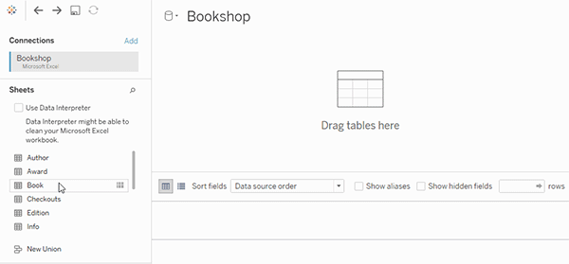
3. Select Open from the menu or double-click the first table to open the join canvas (physical layer).
4. Double-click or drag another table to the join canvas.
5. Click the join icon to configure the join. Add one or more join clauses by selecting a field from one of the available tables used in the data source, choosing a join operator, and a field from the added table. 
6. When finished, close the join dialog and join canvas. You can see the details of the join formed in the data source pane.

**Types of Join:** 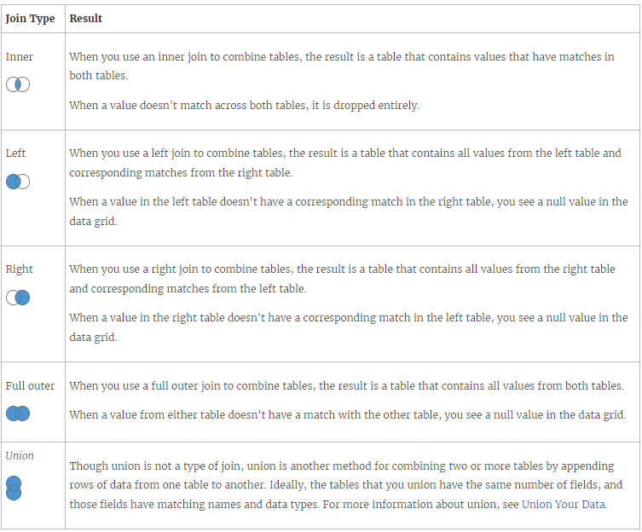

Class Activity:

[Employee Data](https://docs.google.com/spreadsheets/d/1qtca4om7x1lgRi16ACgTCHW-ZZe9x6ua/edit?usp=sharing&ouid=108404179115096419670&rtpof=true&sd=true)

Download the employee excel file and Join the tables Department and Employee. Create a bar graph showing the Bonuses for each employee.